English
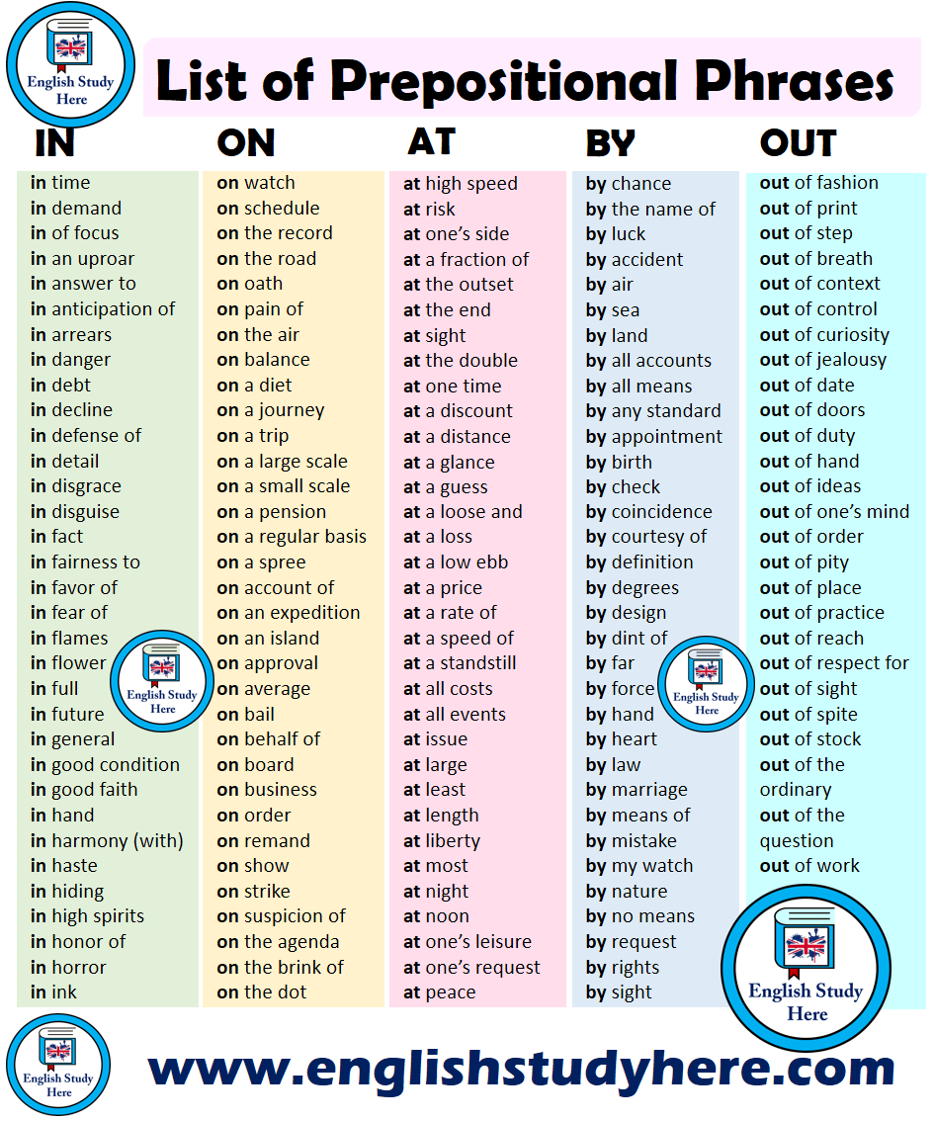
<GEPT Listening CH 8 - 16> 課後練習第一回

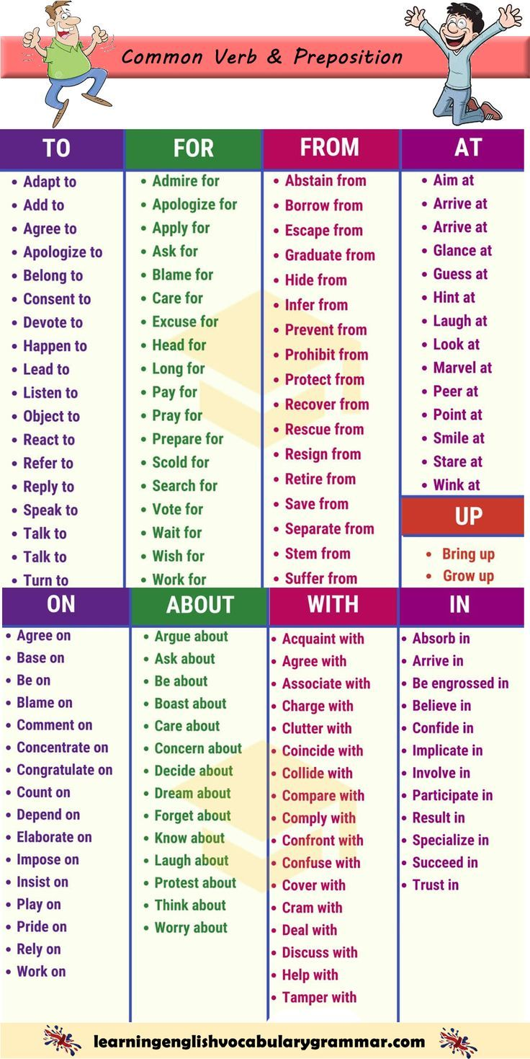
- I guess so.
- I had that same idea.
- That’s exactly how I feel.
- I’d go along with that.
- That’s just what I was thinking.
- Of course.
- That’s exactly what I was thinking.
- Sure.
- I think you are totally right about that.
- That’s right.
- Agreed.
- You took the words right out of my mouth.
- We’re in accord.
- I agree.
- Yeah
- Yep
- Absolutely!
- You’re absolutely right.
- Exactly!
- You got it.
- I could not have said it any better.
- Our thoughts are parallel.
- My thoughts exactly.
- Affirmative.
- No doubt about it.
- I see what you mean…
- So do I.
- I fee that way too.
- Definitely.
- I agree with you.
- Yup
- We are of one mind.
- You can say that again.
- I could not agree with you more my friend.
- You’ve hit the nail on the head.
- You got it dude.
- Our thoughts are absolutely parallel.
- You are so right.

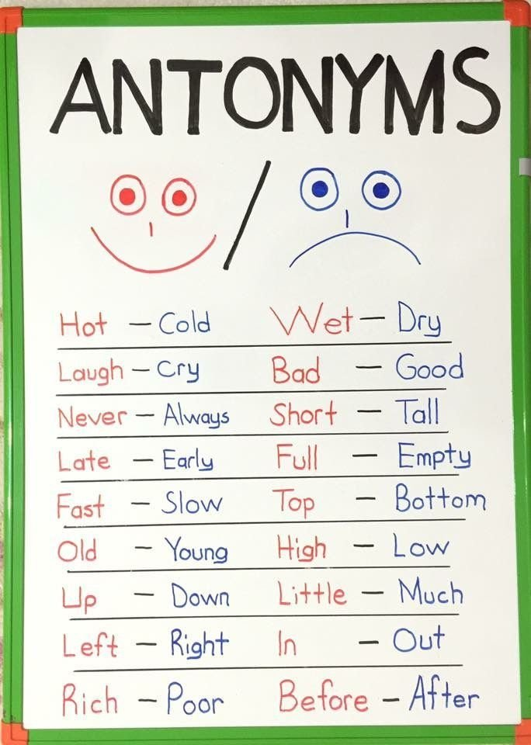
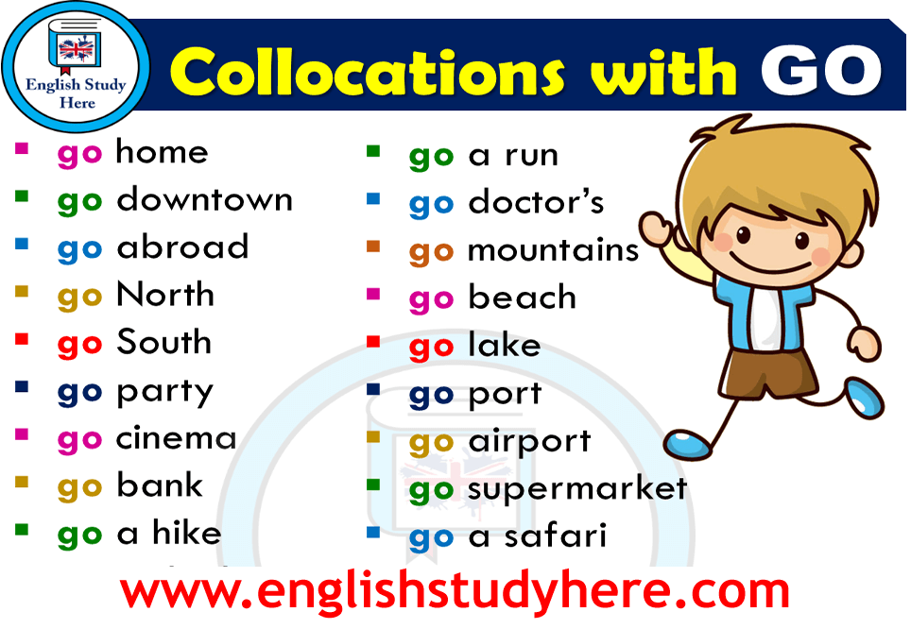
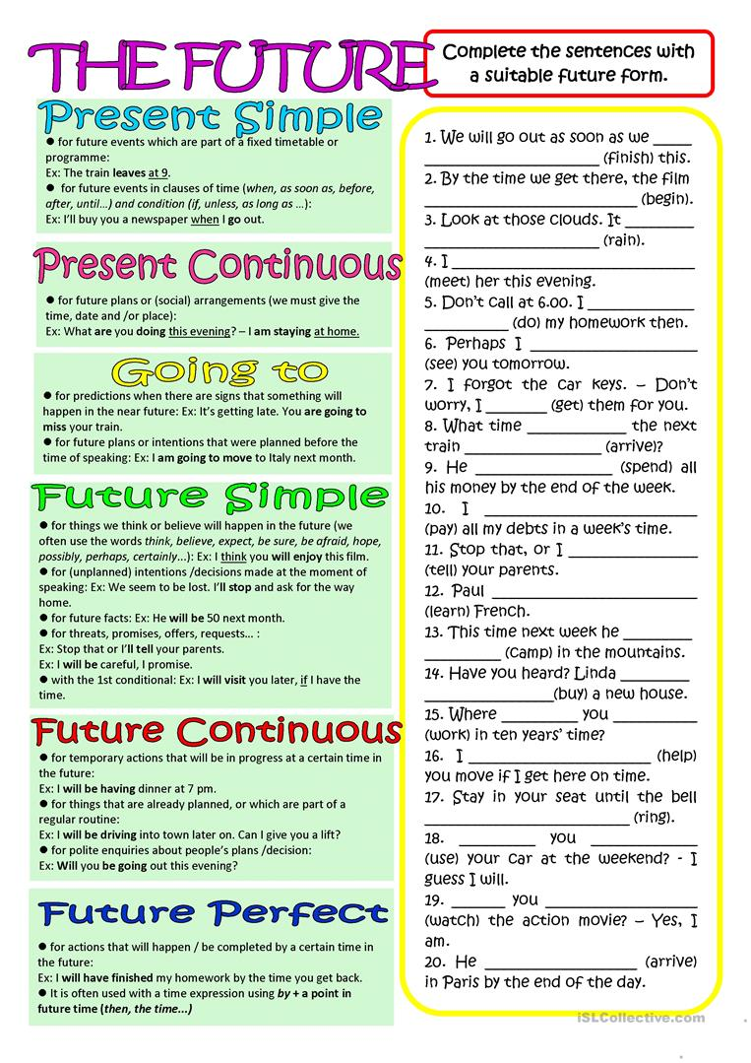
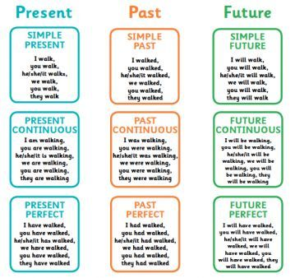
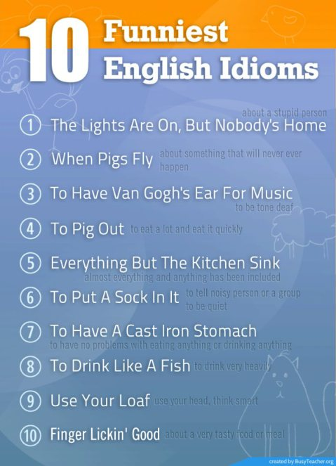
介係詞的分辨

above
across
about
after
against
among
around
at

before
behind
below
but
by
between
beneath
during
For

down
In
inside
except
into
like
near
of

off
since
To
toward
through
under
until
up

with
within

頻率副詞的使用
always
usually
often
sometimes
seldom
rarely
never

地點的介係詞
on
above
around
at
behind
below
beside
between
Far (away) from
in
In back of
In front of
In the middle of
inside
near
Next to
on

.常用的形容詞
Beautifu l←→ ugly
Big ←→l ittle, small
Cheap ←→ expensive
Clean ←→ dirty
Cold ←→ hot
Dangerous ←→ safe
Dry ←→ wet
Easy ←→ hard, difficult
Good ←→ bad
Happy ←→ sad
Large ←→ small
Long ←→ short
Noisy ←→ quiet
Old ←→ new, young
Poor ←→ rich
Sour ←→ sweet (salty)
Strong ←→ weak

angry
important
bright
intelligent
busy
interesting
delicious
kind
famous
lazy
favorite
nervous
free
nice
fresh
ripe
honest
serious
hungry
wonderful

複數寫法判別
After “s”. “z”. “sh”. “ch”. “ge/dge”→ -s/-es
Irregular plural: nouns
Singular | plural
child | children
foot | feet
man | men
mouse | mice
tooth | teeth
woman | women
fish | fish

連綴動詞
is | Was, were | been
become | became | become
grow | grew | grown
turn | turned | turned
prove | proved | proved
look | looked | looked
feel | felt | felt
sound | sounded | sounded
smell | smelled | smelled
taste | tasted | tasted
appear | appeared | appeared
remain | remained | remained
keep | kept | kept
stay | stayed | stayed

8.
9.
10.
11.

